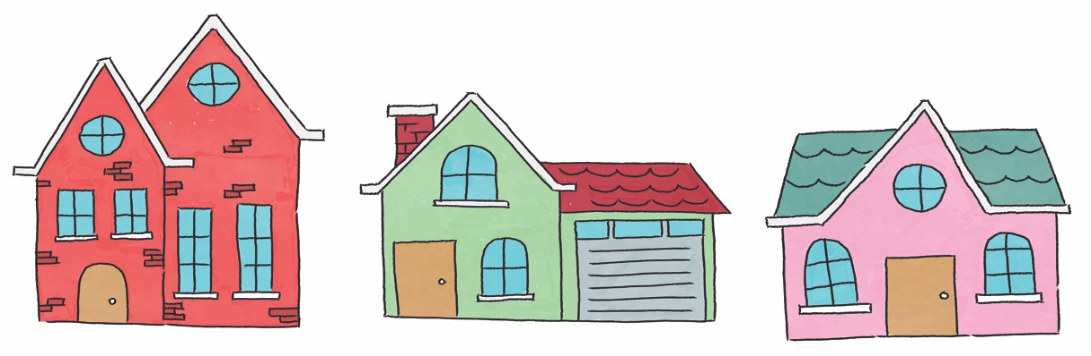

Your Property Checklist
Address:
Letting Agent/Landlord:
Price per Month/Week:

Before you view any house, be sure you’re happy with the location, cost and any roommates you’re choosing to live with. Once a viewing is booked, write down the details for each house so you’re prepared:

Don’t forget to ask questions during the viewing and note the answers as you go:

Utilities
- How much are the bills per month?
- Is the house easy to heat?
- Are water charges included in the rent?
- Is there an option to go ‘bills included’?
- Is Wifi included? What’s the connection speed like?
- Can you see the most recent gas & electric certificates?
- How well does the shower work? (Check the water pressure, you don’t want a trickle!)
- If there is more than one bathroom, can two showers be used at once?
- Do all the sinks drain efficiently?

Security
- Does the property have a working burglar alarm?
- Is the house easy to secure?
- Are all the external doors solid?
- Does the property have double glazing?
- Do the downstairs windows have locks?

Furnishings
- Does the house have all the necessary furnishings you need?
- Does any of the existing furniture belong to the current tenants?
- Are all the furnishings in good condition? Including carpet/wallpaper etc.
- Are the beds in good condition? Are they comfortable?
- Are there any signs of damp? Look out for damp smells and patches of grey/black mould on the walls.

Kitchen
- Is there enough storage for the number of occupants?
- Is the fridge/freezer big enough?
- Is the kitchen/dining space big enough for the occupants?

Exterior
- Is the garden/exterior maintained by the Landlord?
- Have the gutters got weeds growing out of them?
- Is there space for parking or bike storage?
- Do you need a parking permit?

Contract
- Does the contract clearly state what the rent includes?
- Do you know which tenancy deposit scheme your deposit will be held in?
- Do you need a guarantor?
- Is contents insurance included?
- Do you know what type of contract you’re signing?
- Do you know when the contract begins and ends?
- Who manages the property? Your dealings will be with them.

Money
- Are there any extra fees? Admin fees etc.
- Is there a summer rent discount?
- How is the rent paid? Monthly/termly/quarterly?

General
- What do the tenants think of the landlord/agent? Have their needs been met?
- Does each room have enough sockets?
- Does anything need fixing before you move in? Get any agreement in writing.
- Are there shops nearby?
- Is public transport accessible?
- Are any extra services included? Window cleaning, gardening etc.
- Is the Landlord a member of the Unipol Code?

